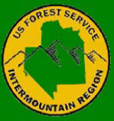
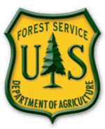
Nomination Form
Region 4
Crosscut Workshop Nomination Form

Workshop dates: April 6-9, 2026
Location: Carson City Ranger District, Humbolt-Toyiabe National Forest
Name:
Region:
Forest/District/Organization/group:
Sponsor:
Email/Phone:
Mailing Address:
Forest Saw Coordinator/ Point Of Contact email:

- Current Crosscut Sawyer Certification Level, Expiration date and Restrictions:

- : Date, Location and Certifier of most Recent Recertification:

- Number of Seasons Using a Crosscut Saw As Part of Employment:

- If you have instricted others for Crosscut Saw Use, Describe:

- Current Chainsaw Certifications and Experience:

In Case Of Emergency
Emergency Contact:
Relationship:
Phone:

Supervisor:
Phone:

